 **Online Book Store**

**Requirements Specification Document**

**Version II**

Prepared by

**TEAM ALLIANCE**

Team Members

Jiaxing Lu (liujiaxinq@qq.com)

Kancharla Kiran Reddy ([kiran.kancharla92@gmail.com](mailto:kiran.kancharla92@gmail.com))

Christopher James (cjames1201@my.mwsu.edu)

Azharuddin Mohammed(azharuddinhussaini1989@gmail.com)

October 5, 2015

Contents

1. Introduction/Overview 1

1.1 Purpose 1

1.2. Scope 1

1.2.1. Main Objective 1

1.2.2. Specific goals 1

1.3. Overview of Document 1

2. Users 2

2.1. Who are the users? 2

2.2. UML diagrams: 2

3. System 5

3.1. Functional Requirements 6

3.1.1. Issues 6

3.1.2. Major Subsystems or Functions 6

3.1.3. Major classes identified: 6

3.1.4. Minor system functions: 7

3.2. User Interface Specification 7

3.3. Non-functional requirements 7

3.3.1. Management 7

3.3.2. Technical 7

3.3.3 Performance 8

3.4. System Evolution/Maintenance 8

4. Other Deliverables 8

5. Glossary 8

6. References 8

# 1. Introduction/Overview

## 1.1 Purpose

The purpose of this document is to specify the requirements of the **online book store** and to inform the customer about the development of the intended systems such as hardware and software requirements, major users, both major and minor functions, constraints, and intended user interface.

## 1.2. Scope

### 1.2.1. Main Objective

The main objective is to create an online bookstore, which gives access to users for ordering the books. There are two kinds of users of the system: bookstore managers (administrators) and customers. The Online Bookstore System will mainly achieve the following two categories of functions: customers will be able to choose books, create orders, buy books, and other functions; and the admin can perform backend management functions. A typical online bookstore generally has the need to dynamically display books’ information, shopping cart management, member management (including membership information registration) and order processing.

### 1.2.2. Specific goals

The specific goal is to create a website for an online bookstore to perform efficiently and should give access for all the users to search for the books and order multiple books at a time.

## 1.3. Overview of Document

The following document is arranged as follows. Section 2 describes the users of the system and shows Unified Modeling Language use case diagrams. Section 3 specifies the target and development environment and it also discusses about functional requirements, user interface specification and non-functional requirements of the system. Functional requirements deal with issues, major functions, major classes and minor system functions. Whereas, non-functional requirements include constraints such as management, technical, and performance of the system. User interface specification shows a mockup screen of the application. Other deliverables required for this project are mentioned in Section 4. The Glossary of this document is present in section 5 and the references are listed under Section 6.

# 2. Users

## 2.1. Who are the users?

The user of this application is anyone who is looking to buy books.

## 2.2. UML diagrams: below are the figures for UML diagrams.

Figure 1 Illustrates the use case diagram for the online book store. It shows the interaction between the user and the system. It also shows the interaction between manager and the system.

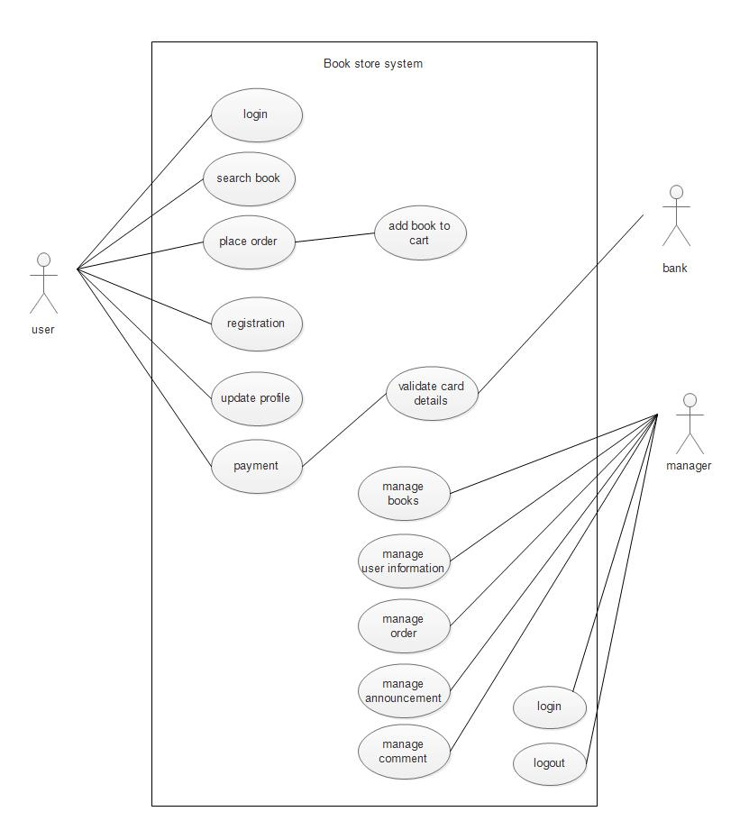

Figure 1. Use case diagram

Figure 2 represents the class diagram. Basically, there are four major classes defined where the user class is being connected to all the other classes. The user class contains the user id, user name, user password and all the information about the user. The operations include adding, deleting, and updating information about the user. The book class has all the information about the books. The activities include adding new books, updating books, and deleting books as required. The manager class contains user id and password of the manager and the operations include deleting, updating, and adding books in the store. The order id class has all the information about the books ordered by the user and operations include adding, deleting, and updating the order.

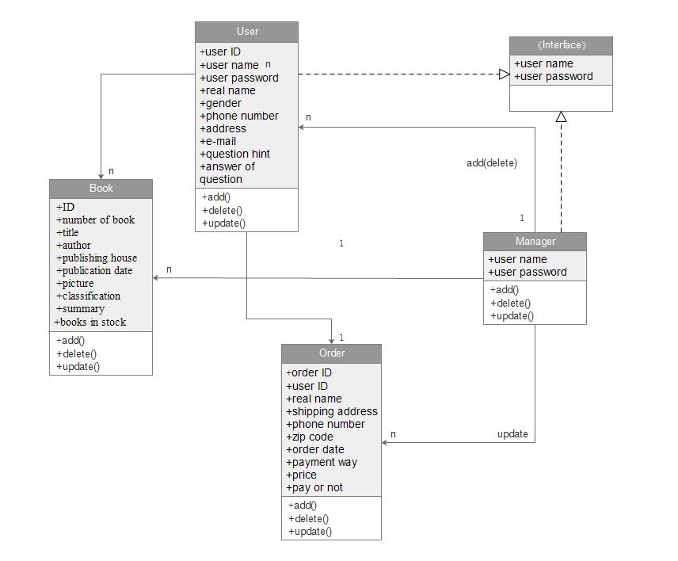

Figure 2. Class diagram

Figure 3 and 4 illustrate the sequence diagrams for add book and check out respectively. Add book sequence diagrams shows you the sequence of steps to be followed for adding a book to the cart. Similarly, the checkout sequence diagram shows you the steps to be followed to check form the book store.

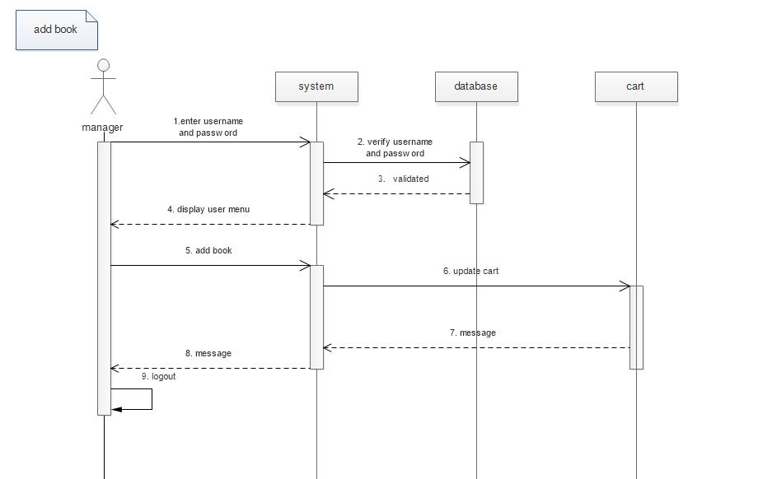

Figure 3. Add book sequence diagram

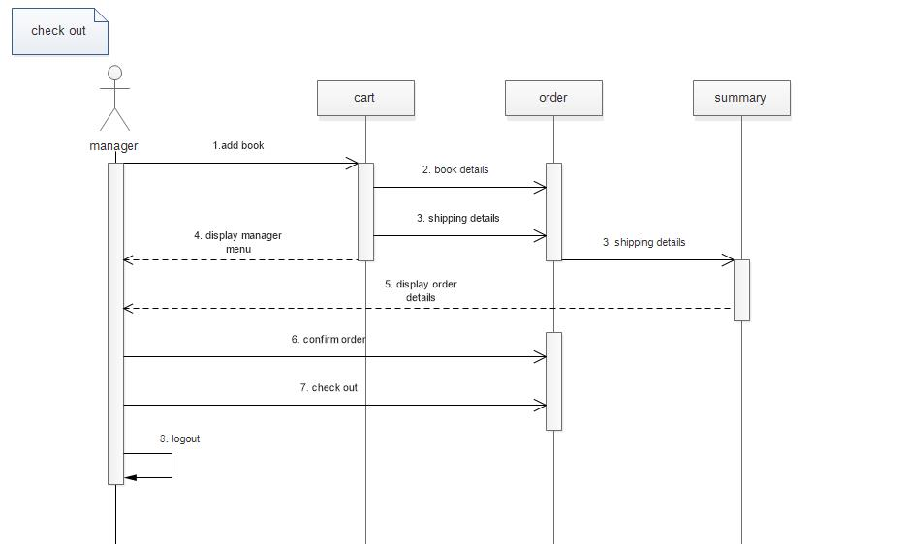

Figure 4. Check out sequence diagram

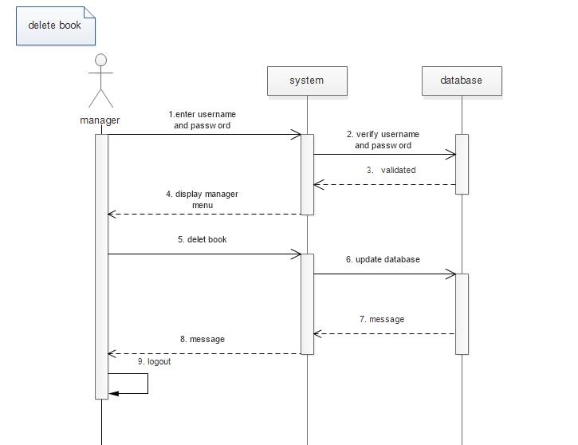

Figure 5. Delete book sequence diagram

# 3. System

The system describes here concern the development environment will be as follows:

**Hardware:** will include a personal (desktop or notebook) computer with the following specifications:

Processor : Dual core

Memory Ram : 1 GB

Hard Disk : 40 GB

Hard Disk : 40 GB

**Software Requirements:**

The system software requirement to run the application:

Development : PHP, HTML, JAVASCRIPT

Database : SQL Server

Operating System : Windows 7/8/8.1/10

Web browser : Internet explorer, Chrome, Mozilla

## 3.1. Functional Requirements

### 3.1.1. Issues

We have to provide the user the access to register, login order books and check out.

### 3.1.2. Major Subsystems or Functions

Book Information Management module provides a quick search function according to title and also provides a classification search of all books. In addition, the system will show all the details of the book, after the customer selects a book. Shopping Cart Management module maintains each customer's shopping cart in the online bookstore. This means recording all the selected books information to the customer’s shopping cart. Member Management module authenticates customer registration information. Currently goods are delivered to the customer’s door or by mail. Therefore, we need to collect the customer's real name, address and contact information. Order Management, according to the books’ information in a customer's shopping cart, and the customer’s preferences on the method of shipping and payment, as well as customer's information, the system creates an order. Books Management module authenticates administrators which can go into the backend page and modify the database of books. An admin can add books; delete books, post book information, and other functions. Comment Management module implements functions of allowing customers to place comments on books and allows administrators to delete comments. Announcement of Information, the administrator can post, modify and delete announcements on the bookstore site.

3.1.3. Major classes identified: Four major classes are needed for system.

**Books:** The user class contains the user id, user name, user password and all the information about the user. The operations include adding, deleting, and updating information about the user.

**User:** The book class has all the information about the books. The activities include adding new books, updating books, and deleting books as required.

### **Administrator:** The manager class contains user id and password of the manager and the operations include deleting, updating, and adding books in the store.

### **Orders:** The order id class has all the information about the books ordered by the user and operations include adding, deleting, and updating the order.

### 3.1.4. Minor system functions:

### 

### The system shall display the reviews and ratings of each product, when it is selected. The system shall enable the user to enter their reviews and ratings. The system should display all the available promotions to the user

## 3.2. User Interface Specification

The system shall provide a uniform look and feel between all the web pages. The system shall provide a digital image for each product in the product catalog. The system shall provide use of icons and toolbars.

## 3.3. Non-functional requirements

### 3.3.1. Management

Due to this being a student-developed project, there will be no cost incurred on our part. Project must be developed during the Fall semester and completed by December 2015. Periodic reviews and testing of the listed functions should be conducted to ensure that the project meets the requirements.

### 3.3.2. Technical

To make this software highly reliable, testing will be performed several times during the development of the project. Testing will include unit testing, integrated testing, interface testing, and another related testing. The efficiency of disk space and memory will be specified later in development phase. The prototype should also be user-friendly, so as to impress those to whom it is demonstrated.

### 3.3.3 Performance

The product shall be based on web and has to be run from a web server. The product shall take initial load time depending on internet connection strength which also depends on the media from which the product is run. The performance shall depend upon hardware components of the client/customer.

## 3.4. System Evolution/Maintenance

This application should be developed in a way as to make it easier for future developers to maintain or enhance the application.

# 4. Other Deliverables

At the end of the project, a project plan, requirements specification document, test plan, test report, prototype, final report and user manual outline will be delivered to the customer.

# 5. Glossary

Database – The file containing the collection of data for the software.

SQL Server – Database management software.

Microsoft® Project – Scheduling software from Microsoft Corporation.

Waterfall Process Model - framework for managing product development.

# 6. References

[1]. Sommerville I.,“Software Engineering 9th edition”.

[2]. Pressman Roger S., “Software Engineering – A Practitioner’s Approach 7th edition”.

[3]. Si Alhir S., “UML in a nutshell”.

[4]. Fowler M., “UML Distilled –third edition”.